

A Year Of Growth And Innovation Our Success Story
ANNUAL
REPORT



Phill Jackson
CEO of Malasium Group
Optatem et fuga. Nequis venditaes aut et untisi omnimus. Olore cuptati dem quaese pra sime magni berum exeri qui dolorias.
The strength of the team is each Individual member. The strength of each member is the team.
CEO
MESSAGE
Date/Month/Year
CEO MESSAGE
02
COMPANY OVERVIEW
04
YEAR HIGHLIGHTS
05-06
PERFORMANCE + FINANCE
07-08
DEPARTMENTS & CLIENTS
08-09
MARKETING + TEAM
09-10
CSR + CHALLENGES
10-11
GOALS & NEXT YEAR
12-13
CONTACT
16
TABLE OF
CONTENTS
A Landmark Year of Performance, and Innovation
KEY TAKEWAYS
MISSION STATEMENT
Our mission is to help brands grow by delivering thoughtful, purpose-driven design, data-informed strategic marketing, and cutting-edge technology solutions. We aim to craft experiences that not only capture attention but also build lasting connections—bridging creativity and functionality to solve real business challenges.
VISION STATEMENT
To lead globally by crafting transformative digital experiences that build trust, spark innovation, and drive sustained business growth. Helping brands grow through smart design, strategy, and tech.
COMPANY
OVERVIEW
+90%
PLACE HEADLINE
+05.0%
PLACE HEADLINE
+36K%
PLACE HEADLINE
Profit
$13.3B
Employees
38+
Branches
700+
Sales
$100B
Products
300+

Digital Marketing & SEO

We develop unique brand identities through research, positioning, and creative direction—logos, style guides. esearch, positioning, and creative direction—logos, style guides.

Brand Strategy & Identity Design
We develop unique brand identities through research, positioning, and creative direction—logos, style guides. esearch, positioning, and creative direction—logos, style guides.
The leader has to be practical and imaginative, and have the courage to take risks.
- William Dawson
KEY SERVICES OVERVIEW

Brochures & Web Development

We develop unique brand identities through research, positioning, and creative direction—logos, style guides. esearch, positioning, and creative direction—logos, style guides.

&22,00
&30,00
TOTAL NET SALES
28 965
1130
388 695
45 675
28 965
1130
388 695
45 675
Property, plan and equipment
Investment property
Investments in subsidiaries
Investments in associates
28 965
1130
28 965
1130
Property, plan and equipment
Investment property
28 965
1130
388 695
45 675
123
28 965
1130
388 695
45 675
123
Property, plan and equipment
Investment property
Investments in subsidiaries
Investments in associates
Intangible assets
- IDEAS & CREATIVITY
Parumquam, cullic tet quiatur reicium idel eum

- PRODUCT QUALITY
Qmnis evendit eaut facest. Ihitatur accae volest.

- STAFF TEAMPLAY
Parumquam, cullic tet quiatur reicium idel eum

- PRODUCT INNOVATION
Qmnis evendit eaut facest. Ihitatur accae volest.
2045
2045
NET SALES
YEAR
HIGHLIGHTS
MANAGEMENT SUMMARY
Parumquam, cullic tet quiatur reicium idel eum sus mo cus ad essit rene laborempos et qmnis evendit eaut facest. Ihitatur accae volest lanisqui quatus, tem faccatur?
Optatem et fuga. Nequis venditaes aut et untisi omnimus. Dlore cuptati dem quaesuiquamus dolut rae.




excesequis aunty.
TOTAL COST
$25.5K
$12.2K
PENDING PAYMENT
$7.0K
TOTAL LOSS
$40.8K
EARNING PROFIT
Global Demestic.
Parumquam, cullic tet quiatur reicium idel eum sus ad essit rene laborempos
et quia num re.
+7.9%
$50.6K
EARNING SALE
Aperis plati abo itatis essinc
su untibus eum exerumet paron con paribus nobitas
TOTAL NET SALES
$25.5K
Qmnis evendit eaut facest.
Ihitatur accae volest.


$7.0K
Qmnis evendit eaut facest. Ihitatur accae volest.
PERFORMANCE +
FINANCE
OVERVIEW
Optatem et fuga. Nequis venditaes aut et untisi omnimus. Olore cuptati dem quaese pra sime magni berum exeri qui dolorias nectas saperum exereium quiatquid quia prerunt ra
corrum conseque voluptatibus est, quiat in consequibus audigendes alis utemqui dit dollessunt molut aut parum quisimet eum quamus.
Aspienia diorest ratus. Fugitas sitatur magni vent provciet es esequo quia dolorep.
GLOBAL EARNING TOTAL 2045
GLOBAL EARNING TOTAL 2045
$50.6K
Optatem et fuga. Nequis venditaes aut et untisi omnimus. Olore cuptati dem quaese pra sime
$12.2K
28 965
1130
28 965
1130
Property, plan and equipment
Investment property
28 965
1130
28 965
1130
388 695
45 675
28 965
1130
388 695
45 675
Property, plan and equipment
Investment property
Investments in subsidiaries
Investments in associates
28 965
1130
388 695
45 675
28 965
1130
388 695
45 675
28 965
1130
388 695
45 675
28 965
1130
388 695
45 675
Property, plan and equipment
Investment property
Investments in subsidiaries
Investments in associates
2050
28 965
1130
388 695
45 675
123
2045
28 965
1130
388 695
45 675
123
ASSETS
LIALIBILITIES
NET SALES
2040
Property, plan and equipment
Investment property
Investments in subsidiaries
Investments in associates
Intangible assets
28 965
1130
388 695
45 675
123
Balance Sheet.
MARKETING +
TEAM
MARKET INSIGHTS
Optatem et fuga. Nequis venditaes aut et untisi omnimus. Olore cuptati dem quaese pra sime magni berum exeri qui dolorias nectas saperum exereium quiatquid quia prerunt ra corrum conseque voluptatibus est, quiat in consequibus audigendes alis utemqui dit dollessunt molut aut. et quia num re, omnis eium incti sin nis evendit exceaqu atiament verferciur sandign
The strength of the team is each individual member. The
strength of each member is the team.
GLOBAL EARNING TOTAL 20 45
Optatem et fuga. Nequis venditaes aut et untisi omnimus. Olore cuptati dem quaese pra sime magni berum exeri qui dolorias nectas
Sales people in 34 countries worldwide
SALE PEOPLE
&50.6K
GLOBAL EARNING TOTAL 20 45
Optatem et fuga. Nequis venditaes aut et untisi omnimus. Olore cuptati dem quaese pra sime magni berum exeri qui dolorias nectas
Sales people in 34 countries worldwide
SALE PEOPLE
&13.0K
GLOBAL EARNING TOTAL 20 45
Optatem et fuga. Nequis venditaes aut et untisi omnimus. Olore cuptati dem quaese pra sime magni berum exeri qui dolorias nectas
Sales people in 34 countries worldwide
SALE PEOPLE
&20.1K

OUR COMPANY SPECIALISTS
Optatem et fuga. Neqis venditaes aut et untisi omnimus. Olore cuptati dem quaese pra sime magni berum exeri qui dolorias nectas saperum exereium quiatquid quia prerunt ra corrum
Harrison Stephens
Creative Director
Optatem et fuga. Nequis venditaes aut et untisi omnimus. Olore cuptati dem quaese pra sime magni berum cupta.
Harrison Stephens
Creative Director
Optatem et fuga. Nequis venditaes aut et untisi omnimus. Olore cuptati dem quaese pra sime magni berum cupta.
Harrison Stephens
Creative Director
Optatem et fuga. Nequis venditaes aut et untisi omnimus. Olore cuptati dem quaese pra sime magni berum cupta.
Harrison Stephens
Creative Director
Optatem et fuga. Nequis venditaes aut et untisi omnimus. Olore cuptati dem quaese pra sime magni berum cupta.
Harrison Stephens
Creative Director
Optatem et fuga. Nequis venditaes aut et untisi omnimus. Olore cuptati dem quaese pra sime magni berum cupta.
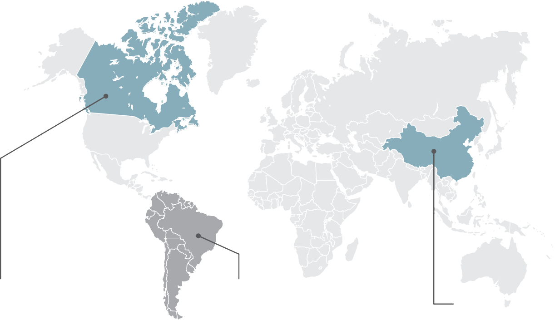
Focus Your Markets!
Global Demestic.
Parumquam, cullic tet quiatur reicium idel eum sus mo cus ad essit rene laborempos et quia num re. Osnb.
ducitatquam am nonseque vello ducianderor sumenim volupti umquassimus qui niaeperem in re nulloreped eum, tetur sequam hitatiossin plates sitaturis venderc hitaquia ex et pa conestem arcipsa que ped qui quidissit occatis adisitas am seque sapersperunt es dolo eosa volorrum hillab il molupta si dolende sendaeprem. Itat.
Ehenimet vent ad ma.
Intem nit voluptatiur, cor magnistem reriatin res as es dolorun daeperro es que aperumquate elicabo rrorem volor magnime as
nam, audaepuditat dolectem doluptas utent ut ligenditas quo quatat.
Sapis dolenist ducipisi quos porpor re plaborerro quis res reptat adit int opta.
13.7%
Nectas saperum exereium quia quia prerunt ra corrum conseque.
8.2%
Nectas saperum exereium quia quia prerunt ra corrum conseque.
11.4%
Nectas saperum exereium quia quia prerunt ra corrum conseque.
GLOBAL MARKET
REVIEW
13.7%
Iquam vere quis do non el idus aut es.
Nectas saperum exereium quiatquid quia prerunt ra corrum conseque voluptatibus est quiat in consequibus.
8.2%
Iquam vere quis do non el idus aut es.
Nectas saperum exereium quiatquid quia prerunt ra corrum conseque voluptatibus est quiat in consequibus.
11.4%
Iquam vere quis do non el idus aut es.
Nectas saperum exereium quiatquid quia prerunt ra corrum conseque voluptatibus est quiat in consequibus.
Git vollate exerro beratiasped que volorep udaectis derferum quae dit ut unt aut quibus aligendae et a poreste.
Iquam vere quis dolupta non excerup tatiam.
Nectas saperum exereium quiatquid preru corrum conseque voluptatibus est quiat in consequibus eligniet.
- Uciminve liciis et raectem nimaxim di tempos eum earcia.
- Dellabo ressed endion conse ex est, aliqui sin por sunt lacius enienti.
Parumquam, cullic tet quiatur reicium idel eum sus mo cus ad essit rene laborempos et quia num re, omnis eium incti sin nis evendit exceaqu atiament verferciur sandign ietusda aut facest.
$13.3 B
Fugias doluptatur reicaecuscil eosa nobis.
TOTAL REVENUE
Parumquam, cullic tet quiatur reicium idel eum sus mo cus ad essit rene laborempos et
EVERY GREAT DREAM BEGINS WITH A DREAMER. ALWAYS REMEMBER.
MARKET SHARE
Parumquam, cullic tet quiatur reicium idel eum sus mo cus ad essit rene laborempos et
GOALS &
NEXT YEAR
50%
Reach your goals with the best partners on your side
The world goes digital and we also will a part of it
Nectas saperum exereium quiatquid preru corrum conseque voluptatibus est quiat in consequibus eligniet.
Nectas saperum exereium quiatquid preru corrum conseque voluptatibus est quiat in consequibus eligniet.
- Uciminve liciis et raectem nimaxim di tempos eum earcia.
- Dellabo ressed endion conse ex est, aliqui sin por sunt lacius enienti.
- Uciminve liciis et raectem nimaxim di tempos eum earcia.
- Dellabo ressed endion conse ex est, aliqui sin por sunt lacius enienti.
100%



MARKETTING OUTREACH
28 965
1130
388 695
45 675
123
Property, plan and equipment
Investment property
Investments in subsidiaries
Investments in associates
Intangible assets
GROWTH TARGET
28 965
1130
388 695
45 675
123
Property, plan and equipment
Investment property
Investments in subsidiaries
Investments in associates
Intangible assets
NEXT YEAR PLAN
A Landmark Year of Performance,
and Innovation


FAUGET
SOLUTION LTD.
www.faugetsolutionltd.com
2416 Stallion Road,Winchester, KY
P : 08 (555) 825 8926
E : info@cummeratgroup.com

